Ray Smith was betrayed and handed over to the Gestapo at the time, but escaped
American crashed in Outer during the Second World War, now grandson returns to the place where it happened: "Overwhelmed and moving" Today at 06:00 by Elke Meert
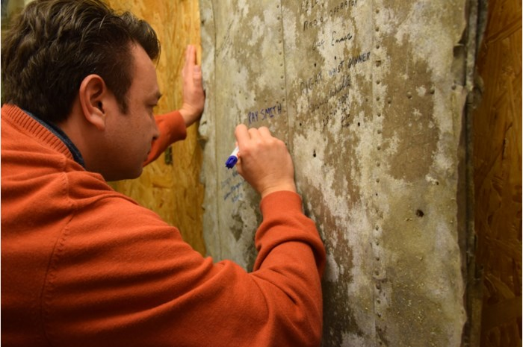
Curtis Steinback signed an aluminum plate of the plane in which his grandfather crashed in Outer.FOTO: EMD
HAALTERT -
On 23 June 1944, American Air Force B-17 ball turret gunner Ray Smith crashed with his bomber in Outer, this week his grandson visits the place where it happened. "That so much attention is paid to my grandfather ... I am overwhelmed and moved."
This week, Curtis Steinback from Los Angeles stayed in our region for a four-day research visit about what happened to his grandfather Ray Smith (1918-1994). Smith was an American Air Force veteran who during the Second World War was as a ball turret gunner in the bomber B-17 'To Hell or Glory'. It crashed on 23 June 1944 in the Lebekestraat in Outer.
"My grandfather never told us about the war. After his death, I started to do research, "says Steinback. "Then I came in contact with Dirk Vijverman, who is curator of the WW II resistance museum De Patrijs '44 in Haaltert, where among other things attention is paid to that plane crash and my grandfather. Magnificent."
After two visits to the only still living survivor of the crash, Henry Schultz, who lives in Florida, a visit to the museum was on his wish list. Together with the people of the museum, they followed in the footsteps of grandfather Smith with a visit to the crash site in Outer, the Gestapo headquarters on Avenue Louise and the prison of Saint-Gilles in Brussels.
"My grandfather was able to hide thanks to the resistance in the region, but was eventually betrayed and handed over to the Gestapo. He spent one week in prison, after which they sent him to Germany with the 'ghost train', together with 1,800 Belgian political prisoners. But they could eventually escape."
Offering
Steinback is very impressed of his visit. "It is touching to see how easy we are and to see those cars driving around, while they could not walk on the streets 75 years ago without fearing their lives," he says. "But with a visit to the cemeteries in Ypres and the Ardennes, I have also seen the centuries of struggle that the Belgians have undergone. I am overwhelmed. It is easy to forget all of that now that spring is coming, but we can not let ourselves be forgotten. We must learn from the past and understand it. The sacrifices they have made for us are incredible."
Alderman of Culture Bart Ottoy (CD & V) and Mayor Veerle Baeyens (N-VA) welcomed Steinback with a basket full of local products. Steinback in turn signed the aluminum plate, from the B-17, in the museum where there were signatures of two crew members and the American attaché in Brussels.

Sunday the 23rd of June is the 75th anniversary of the crash in Outer. At 11 o'clock a commemoration ceremony takes place at the monument.
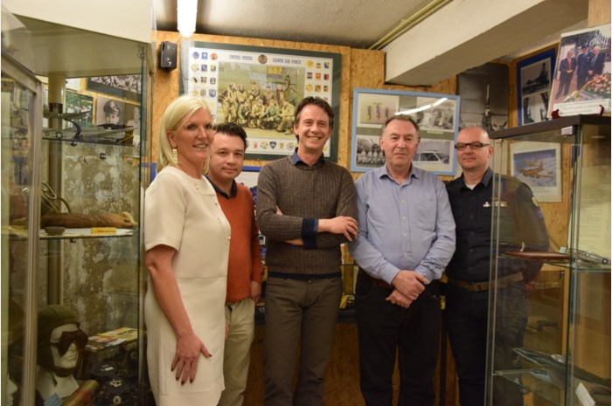
Mayor Veerle Baeyens and Alderman Bart Ottoy and Dirk Vijverman of the museum and re-enactor Tom Liottier welcomed the American Curtis Steinback (second from the left) to the corner about the crash and his grandfather. PHOTO: EMD

