THE U.S. AIR FORCES ESCAPE & EVASION SOCIETY
FALL 2017 Communications
www.airforceescape.org

Volume 29, No. 1 Rochester, NY 14609 November 2017

____________________________________________________________
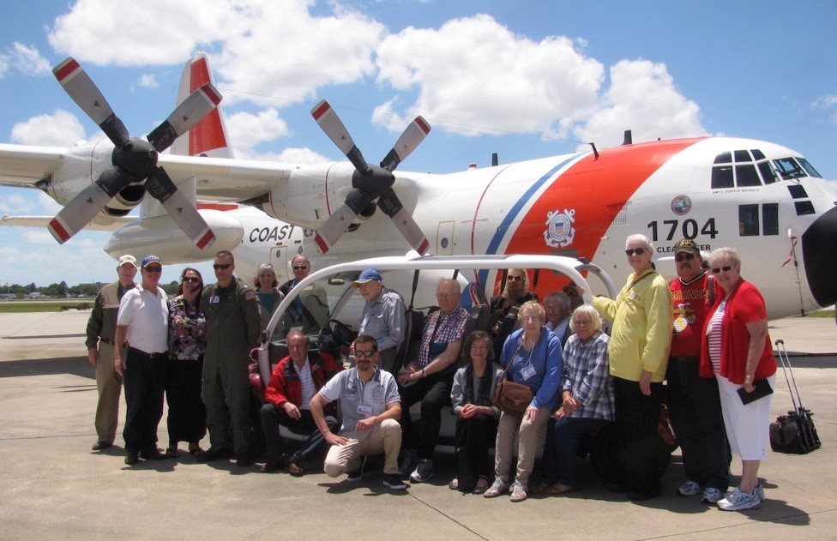

In This Issue:
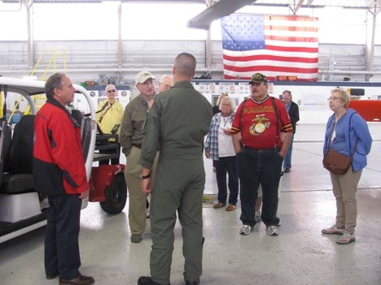
- Membership Form
- Photos from Tampa
- 2018 Reunion in Savannah Info
- Who was Tina Lindeboom?
- AFEES in New Orleans
- Fréteval Forest Evaders Held Reunion
- Polish Partisans Protected Flier
- Brussels Commememorations
- In The Footsteps Of Shelburn
- World War II Flier's Granddaughter Returns to France for Honors
- Movies and Books of Interest
- Folded Wings Visiting the US Coast Guard Base.
- The Prez Sez

ANNUAL AFEES MEMBERSHIP DUES

AFEES annual membership dues:
- $25 per year (includes newsletter emailed to you—please provide email address)
- $40 per year (covers printing & postage if you prefer a hard copy of the newsletter sent to you via US Mail)
- $100 Lifetime Membership—FOR EVADERS ONLY

Please send checks for Membership Dues (payable to “AFEES”) and donations to:
Margaret Fricke, 1517 Trollhagen Drive, Fridley, MN 55421-1351

Name______________________________________________ Amount enclosed_____________

Address _______________________________________________________________________

City and State___________________________________ 9 digit zip code____________-_______

Phone_____________________________________________________

Email__________________________________________________________________________

Emergency Contact Person and phone number

_______________________________________________________________________________

Are you an Evader? YES NO Related to an Evader? YES NO

Relationship__________________

Evader’s name___________________________________________________________________

Evader’s Military unit_____________________________________________________________

Are you a Veteran? YES NO If yes, what Military Branch _________________________

Calendar Date of Military Service___________________________________________________

Do you wish to receive the AFEES newsletter via email instead of via US Mail? YES NO
(please provide an email address if you want an electronic version of the newsletter sent to you)

Other comments or reasons for joining:

______________________________________________________________________________

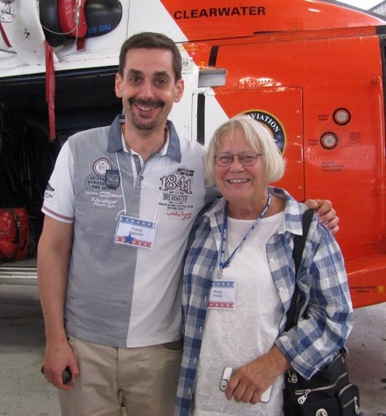
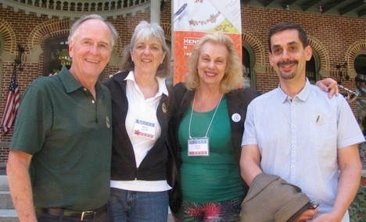
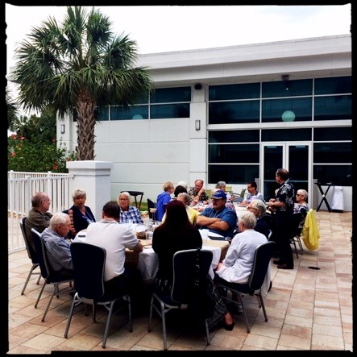
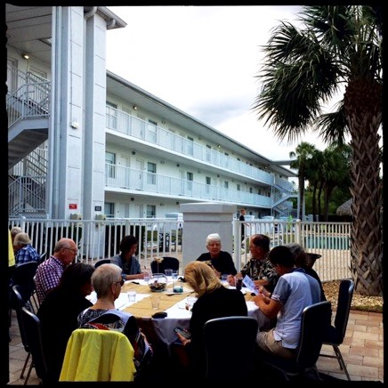
______________________________________________________________________________ Peter

Franck Signorile and Margy Fricke

Sunset Cruise in Tampa, FL

Dennis
Scovill
, Nancy Costello Scoville,
Suzanne

Price, Franck Signorile

2017

TAMPA
REUNION
ATTENDEES:

Allison,
David
Bentley,
William Binnebose, Jane Binnebose,
Bruce Bolinger, Charlotte Bolinger, Lynn
David, Cynthia Forrester,
Margaret Fricke,
Hauer,
June
El
Lois
Hamilton,
izabeth
McDade, Joseph Owens
, Dennis Scovil
l,
Nancy Costello Scovill,
Charles “CB” Screws
,
Franck Signorile,

Beverly
Patton Wand,
Suzanne

Price,
Mary Spinning Shier
,
Francene
Weyland,
John White, Michelle White, Albert
Wieringa, Johanna
“Ankie”
Wiering
a

Al fresco dinner
under the palm trees
at the
Hotel

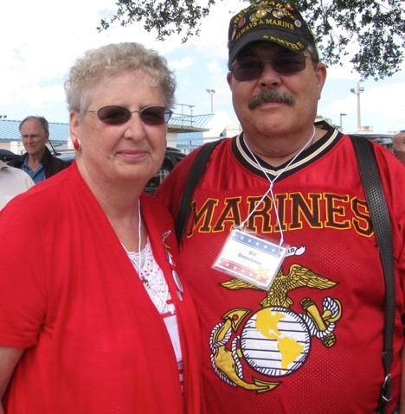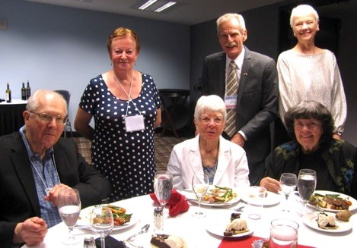

Jane and Bill Binnebose

Standing: Johanna
“Ankie”
Wieringa, A
lbert
Wieringa, Cynthia Forrester

Seated: Bruce Bolinger
, Charlotte Bolinger,
Lois Hamilton

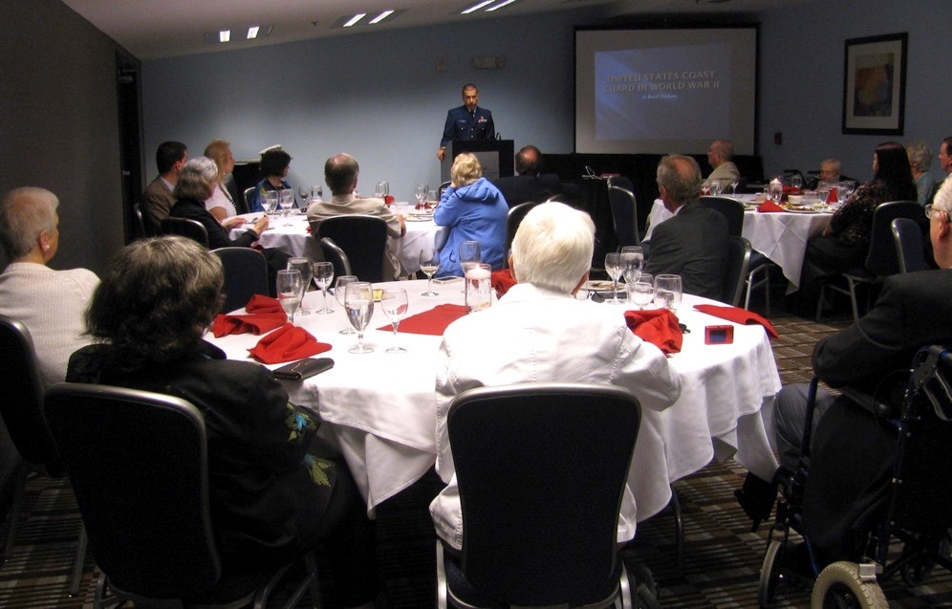

Lt. Eric Kolwicz gave an interesting talk on the history of the Coast Guard during World War 2

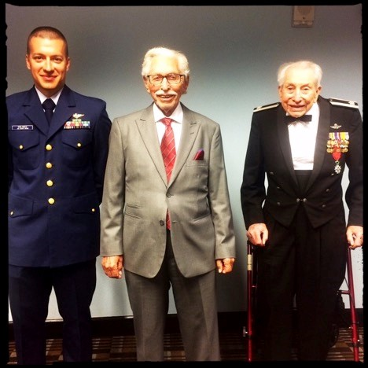
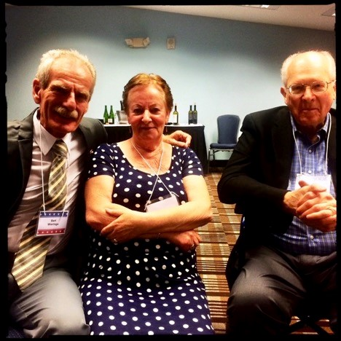
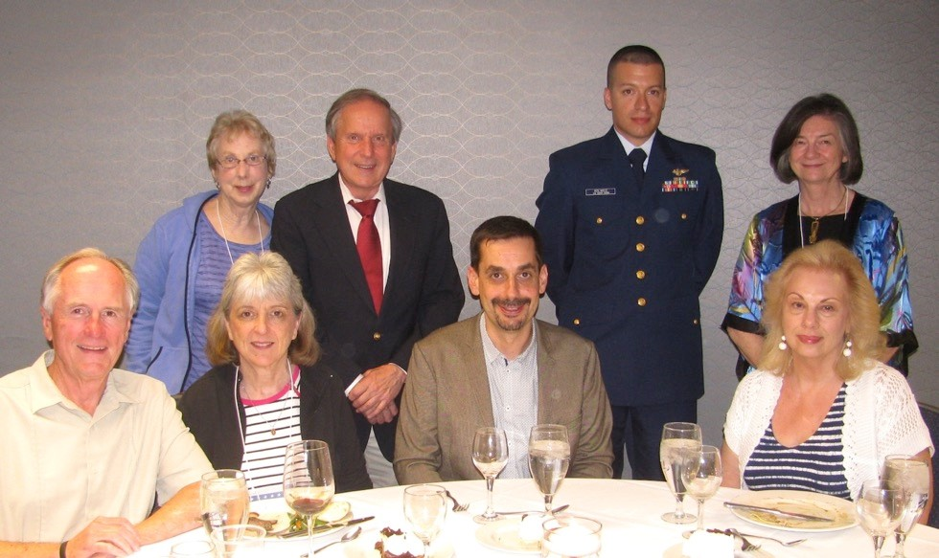
Lt. Eric Kolwicz, Joe Owens, Charles “C.B” Screws.

Standing: Mary
“
Beanie”

Spinning Shier
, Lynn David, Lt. Eri
c Kolwicz, Beverly Patton Wand

Seated: Dennis S
covi
ll, Nancy Costello Scovill, Franck Signorile, Suzanne

Price

Albert and Johanna Wieringa, and Bruce Bollinger. Johanna aka “Ankie” is the daughter of Peek and Nellie de Noo, a couple in the village of Well, The Netherlands who hid Lt. Tom Applewhite in Nov. 1943 for two nights.

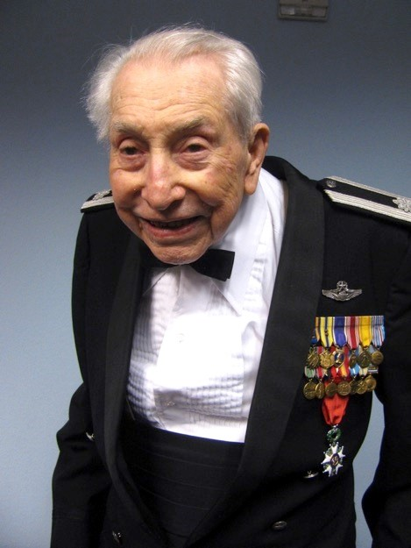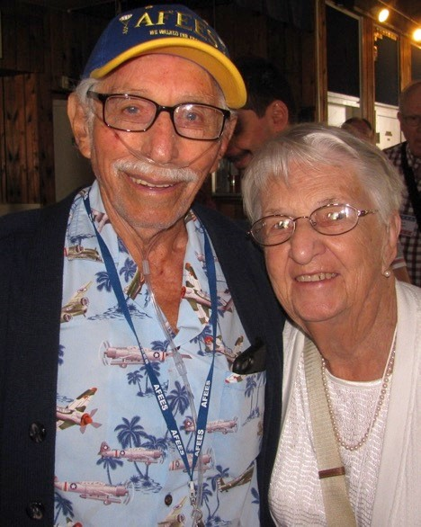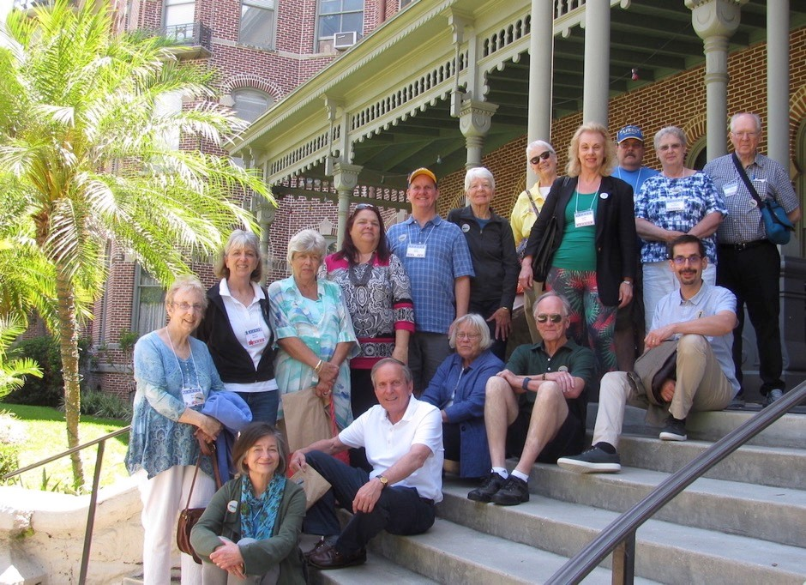

Charles “C.B.” Screws

Joe Owens
and June Hauer

Trip to the Henry B. Plant Museum

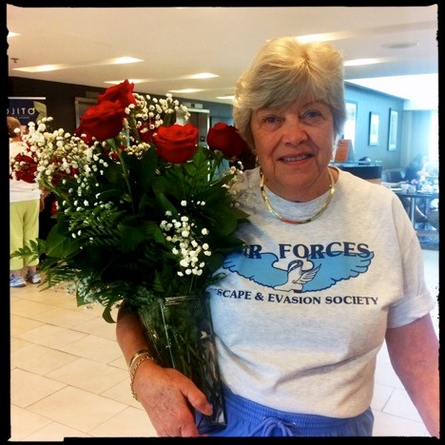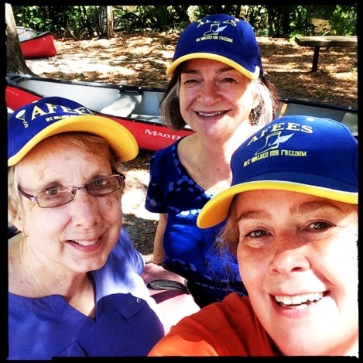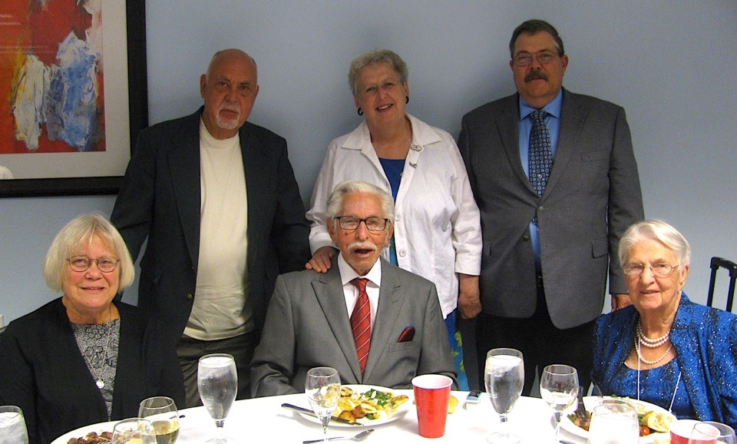

S
tanding: Filmmaker Peter Bentley,

Jane Binnebose, William Binnebose
.

Seated: Margy Fricke, Joe Owens, June Hauer

Francene Weyland Representing AFEES while kayaking: Mary
“Beanie” Shier, Beverly Patton Wand, and
Elizabeth McDade

AIR FORCES ESCAPE & EVASION SOCIETY REUNION

MAY 16 – 20, 2018

HELPERS ONLY: Send both Hotel Reservation Form and Reunion Reservation Form to:

AFEES c/o: Margaret Fricke
1517 Trollhagen Drive
Fridley, MN. 55421-1351
Email: frickej@comcast.net

Everyone else please call the Hilton Garden Inn Airport in Savannah
80 Clyde E. Martin Drive
Savannah, Georgia 31408
Phone: (912) 988-9302 or Fax (912) 964-5150

You may book online by going to the following link:
http://hiltongardeninn.hilton.com/en/gi/groups/personalized/S/SAVAHGI-AFEES-
20180514/index.jhtml
and proceed with selecting the available room type and date(s) of stay.
Group Name: AFEES Reunion Group Code: AFEES

$162.07 per night, inclusive Room type One King or Two Double
ROOM RATES APPLY THREE DAYS BEFORE AND THREE DAYS AFTER REUNION
Reunion Hotel Rates guaranteed only until April 16, 2018.

Check Room type: one King _________________ Two Doubles ____________________
First Name :________________________________ Last Name ______________________
Spouse’s Name _________________________________________________________________
Mailing Address: _______________________________________________________________
City/State/Zip Code: ___________________________________________________________
Phone Number: _____________________________ Email :__________________________
Arrival Date ________________________________ Departure Date: _________________

Number of Adults: __________________________

MAY 16-20th, 2018 AFEES REUNION IN SAVANNAH
by Lynn David & Mary Spiers
We are planning a wonderful reunion in Savannah! Please try to arrive by 12 noon on Wednesday May 16th. We have arranged a 2:30pm tour of the 8th Air Force Museum and a dinner at 5pm on the 16th. The cost for both will be $27.
The Memorial Service on Saturday will take place at the museum Chapel. It should be a beautiful event.
The Hilton Garden Inn Airport in Savannah, Georgia will be our home base. The room rate will be $162.07 per night for one king, one queen, or two doubles (includes all taxes and free breakfast for two). The room rate is available three days before and after the reunion.
The Hilton Garden Inn Airport has a wonderful breakfast buffet which includes eggs cooked any way you like them. Other features of the hotel include:

- Free Wi-Fi throughout the hotel
- Nonsmoking everywhere
- Outdoor pool
- Free parking
- Free airport shuttle (3 minutes) (Taxi cost $10)
- Excellent Business Center
- Exercise room
- Free shuttle to any location within 5 miles of the hotel
- Pillow top mattress, refrigerators, microwave and Keurig coffee maker

We were able to hold the cost for the Thursday Welcome Dinner at $35. The cost for the Saturday Banquet will only increase $2 to $47.
Please call (314) 422-1567 or email Lynn Ldavid@bankconsultants.com as soon as possible so he will know if you plan to attend the reunion.

See you in Savannah!
WHO WAS TINA LINDEBOOM?
By Bruce Bolinger
Nevada City, northeast of Sacramento, California, is a popular tourist attraction because of its Gold Rush history and its mountainous, tree-covered setting.
Its many old buildings include the
Nevada Theatre where Mark Twain and Jack London appeared on stage. In the local chamber of commerce office visitors can consult its index for directions to historic memorials. But, for one memorial, there is no entry. A bronze plaque, located three blocks from downtown Nevada City near the flagpole in front of the Veterans Building, is easily missed by passersby. It reads:

Dedicated to the Memory of Tina Lindeboom,
March 1911-February 1984, With Gratitude and
Appreciation of the American People for Gallant
Service in Assisting Allied Soldiers Escape from the Enemy, W.W. II 1939-1945. VFW Post 2655
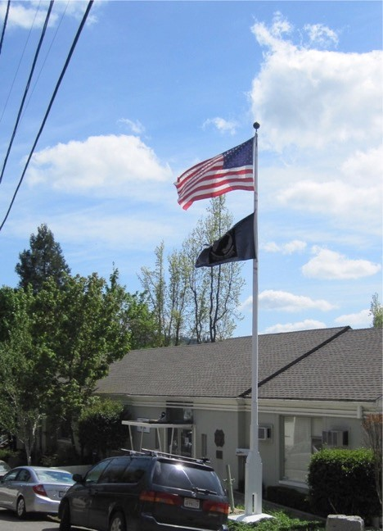

So many years have passed since the memorial to Tina Lindeboom was put in place that no one in Nevada City, not even members of the VFW post, which uses the Veterans Building, know anything about her. But anyone helping Allied airmen shot down over Nazi-occupied countries was subject to being shot or sent to a concentration camp. Memories of those who resisted the Nazis should be preserved. This article seeks to set that right in the case of Tina Lindeboom.
Born in 1911 in Drachten, Friesland, a province in the northwest corner of The Netherlands bordering on the North Sea, Tina grew up in an area of small villages where dairy products, potatoes, and peat-cutting were the mainstays of the economy. Tina was the oldest of nine children, two of whom died as infants. She was very smart and was given more education than the other children who followed. As a result, she was a fluent speaker of English as well as Dutch and Frisian, the predominant language of the province.
By 1929 the family was hard-pressed financially, forcing the family to uproot itself and, with help from a cousin in America, to emigrate. On Nov. 26, 1929, having received permission to emigrate and having sold everything to pay for the trip, they set sail from Rotterdam on the SS Volendam, in its cheap, lower deck, arriving in New York City two weeks later. Imagine the contrast for them between the village of Boelenslaan, where they had been living, which even now has only 1100 inhabitants, and the cities of Rotterdam and New York followed by a nearly 3000 mile cross-country train ride to California. Their final destination: San Bernardino, southeast of Los Angeles, where a cousin of Tina’s father lived.
One thing working in their favor was that a large dairy farming community of Dutch and Frisian speakers had already developed in the southeastern part of Los Angeles County, making it the largest milk-producing region of the state. Dutch farmhouses, cows, and even windmills stretched across what are now the towns of La Mirada, Cerritos, Norwalk, Bellflower, Artesia, and Paramount. There were predominantly Dutch churches, schools, bakeries, social clubs and a Dutch-language newspaper. Dutch and Frisian were as likely to be heard on the streets as English.
Eventually the Lindebooms started their own dairy with Tina’s mother and brother each milking 30 cows, probably twice a day. With her fluency in English, Tina was able to find a job working for a lady in her 90s and very wealthy—Mrs. Thaxtra. It was Mrs. Thaxtra who encouraged Tina to continue her education.
Tina had met a young man, Age
Salverda, back in Friesland. After her family’s move to America, Tina and Age kept in touch by letter. He served as a navigator on a Royal Dutch Shell tanker, which visited ports in Florida but not California. If Age was hesitant to pop the question, it may have been Tina’s decision to begin the process to become a U.S. citizen on Feb. 23, 1933 that forced the issue. Instead of completing the process, Tina returned to The Netherlands on June 30, 1936 and she and Age were married three months later. Their first and only child, Willem, was born in 1937.
Tina and Age had been living in the town of Hilversum, southeast of Amsterdam, when the Germans invaded on May 10, 1940. Little Willem was not quite three. But Age was in the Far East on a voyage when The Netherlands was dragged into the conflict. Age would not be able to see Tina and his son for the next five years. After moving to Arnhem, then Nijmegen, in 1940, Tina settled in the village of Houtighage in the province of Groningen, close to the Friesland border in 1941 in an area where she had relatives and near where she grew up. It probably was fortunate that Tina had not completed her U.S. naturalization. Otherwise she would have been viewed as an enemy alien by the Nazi civilian government that Heinrich Himmler, head of the Gestapo and the SS, had installed in The Netherlands.
By 1943, the U.S 8th Air Force began its bombing missions from England to Nazi Germany, with many of them passing over Friesland. Subject to repeated attack by German anti-aircraft guns and fighter planes, many of the bombers were lost. If lucky, their crews might be able to parachute to safety. And if really lucky, they might be found by members of the local populace willing to risk their own lives to hide the airmen and pass them on through escape lines to safety.
The first airmen were shot down over southeastern Friesland in the middle of 1943. In response, an escape line was formed, drawing from members of other Resistance organizations as well as persons not affiliated with any. The escape organization centered on the city of Drachten plus various villages such as Opeinde and Houtighage, a few miles from Drachten.
The early leader of the escape line was Captain Pieter Wijbenga of Drachten who was the leader of the L.O. (aid to persons in hiding) and L.K.P. (armed resistance) organizations in southeast Friesland and later all of Friesland. Writing after the war, he described how they operated: “At first we had to look after sheltering.” Next came “shoes, clothing, pictures for false identity cards, ration tickets, etc. Housing and clothing were the most difficult problems.” Even though photos were included in the airmen’s escape kits in England, they didn’t meet the requirements for photos on the new ID card forms imposed by the Nazi government. So new photos were made by Dr. Buitenbos, the Dutch Reformed Church pastor in Opeinde, who had a camera and could develop the photos himself, and K. Lammers of Drachten. Transport of airmen was the primary responsibility of Tiny Mulder of Drachten, who had an excellent knowledge of the country. Speaking English fluently, she also handled interrogation of fliers to ensure that they were not German agents trying to infiltrate the line. Medical aid to injured airmen was the responsibility of Dr. Johannes Siebinga of Opeinde. Dr. Siebinga was a highly regarded physician, well-educated, a trained pilot, amateur archeologist, and fluent in German. Some 70-80 airmen were helped by the line. Airmen were transported one-byone or in groups. Every form of transport was used since some airmen had never learned how to ride a bicycle. Conditions sometimes required that airmen be moved repeatedly from one shelter to another, sometimes as many as ten men at a time. The SD (SS secret police) was constantly trying to roll up the line. Captain Wijbenga had to use it himself on October 7, 1944.
Jilles Zyjlstra, a clothing shop owner in Drachten, said, “When fliers had a forced landing in our area, the first thing was to get clothing. As nearly nobody could get new clothing during the German occupation, only a few were able to give any.” So when Zijlstra received any new clothing supplies for his shop, they were used to outfit the airmen rather than customers. Pastor Buitenbos observed that he was lucky; the Germans only searched his house twice and found nothing. They also came for Zijlstra but to arrest him and when they couldn’t find the clothing shop owner (he had been warned in advance), they burned down his house and with it all his possessions.
Buitenbos and Zyjlstra said of the airmen, “All fliers had a proper nursing during their stay in Frisia (Friesland). In most cases they could not walk around freely: some of them were allowed to make a walk in the dark at night. Two fliers sheltered with P. Dijkstra, however, spoke Frisian pretty soon and could be treated as normal ‘underdivers’; by day they cycled around the village and made
visits.”
The file on Tina lists three airmen hidden by her, S/Sgt Paul H. Moseley of Brookfield, MO, right waist gunner, who stayed with her for two weeks in June 1944; waist gunner/tail gunner James Moulton of Albany, Oregon, for one day; and 2nd Lt. Marlow B. Olson of Boyd County, Nebraska, navigator, for two days. Olson and Moseley were members of the crew of the B-24 “Portland Anne” of the 453 Bomb Group and shot down on March 8, 1944. Moulton was with the 385th Bomb Group and went missing in action Aug. 15, 1944. It seems likely that there were more airmen helped by her but the records are incomplete. Tina’s file as a helper of airmen shows her closest contacts were Dr. Siebinga; Jilles Zyjlstra, the clothier; and Pastor Buitenbos. The helpers who delivered airmen to her were Zyjlstra (Moseley), Pieter Blom of Drachten (Moulton), and Arend de Groot of Opeinde (Olson). Blom later drowned in the Wadden Sea while trying to help airmen escape by boat.
On Jan. 3, 1945, the SS secret police came for Tina. Her son, Willem, then seven years old, saw them coming. Knowing that Tina had a pistol he hid it and some incriminating documents in his clothes. As the Germans entered the house, he slipped outside to dispose of the dangerous items.
Tina’s arrest occurred at the same time as that of Dr. Siebinga and his wife. All three were taken to the Blokhuispoort prison in Leeuwarden, 14 miles from Opeinde. En route, Tina, who had not yet been searched, used the opportunity to shred and eat additional documents that she had hidden in her clothes. Blokhuispoort had been the site of a prison for 500 years. It is known for a brilliantly planned raid by the Resistance on Dec. 8, 1944 in which 55 prisoners were freed without a shot being fired.
After severe beatings in Blokhuisport Prison, Dr. Siebinga was transported to Schwarzer Weg Prison, a prison for Dutch male political prisoners in Wilhelmshaven, the major German naval port. Between January and March 1945 seven trainloads of political prisoners, predominantly from Friesland and other northern parts of The Netherlands, carried men, locked in cattle cars, from Leeuwarden to Wilhelmshaven. Schwarzer Weg fitted the picture of a concentration camp, complete with barbed wire and guard towers with machine guns. Men had to subsist on starvation rations, often their barracks had no heat in the winter, there was no water because of frozen water pipes, beatings were administered for minor infractions, such as putting their hands in their pockets to warm them, and everyone was tormented by lice. They were used as forced labor to repair damage from Allied bombings and were at risk of being bombed during Allied attacks on Wilhelmshaven. As the war neared an end and the prisoners were being sent home, Dr. Siebinga dissuaded the SS commander of the town of Delfzijl from his plan to rid himself of the hundreds of emaciated, sick, and foul prisoners by having the barge on which they had arrived torpedoed by German submarines. After Tina’s arrest, Tina’s brother-inlaw, Jan Veenstra, and his wife, Minke, who lived in the nearby village of
Drachtstercompagnie, took in her son Willem. Jan’s brother, Wieger, had emigrated to America in 1930 where he met Tina’s sister, Patricia. They had married in 1936.
Tina was sent to Wernigerode, a subcamp of Buchenwald Concentration Camp. She told her sister Elsie how every day they had to empty the water closet barrels and were not allowed to spill anything. If they did, they were punished. The female guards were worse than the males; they were not human. The prisoners were kicked and beaten a lot. There was little to eat and what food they received was mainly cabbage soup. And they had to work as slave labor in weapons factories. When the Allied armies arrived at the end of April 1945, the prisoners feared that the guards would shoot them because they knew too much. But their liberators arrived much sooner than the guards expected. Because Tina could speak both English and German, she was one of the first to gain her freedom.
When Tina Lindeboom was asked after the war by the Allied Military Intelligence Service to describe her role in the escape organization, she said, “My work really consisted of collecting money and clothing for onderduikers and pilots. One time, when conditions were very unsafe, I had a couple of pilots in my house. Unfortunately, I do not remember any dates. I lost my bicycle during my work with the pilots. I would really like to receive a permit from you which would enable me to obtain a new bicycle.” Tina’s file has a receipt signed by her on 27 Oct. 1945 for one used service bicycle.
Even before the war, Age Salverda’s voyages took him away from home much of the time. Then came the five-year hiatus imposed by the war. That would have been hard on any marriage. Add to that, Tina, in the meantime, had been working closely with Dr. Siebinga in the escape line. Tina and Age decided to end their marriage and were divorced on Jan. 5, 1946. Dr. Siebinga and his wife divorced and he and Tina were wed on Nov. 27, 1946 and had a son.
In 1965 special receptions were held in three different villages the same day in honor of Dr. Siebinga. They were jam-packed with current and ex-patients who wanted to shake hands with him.
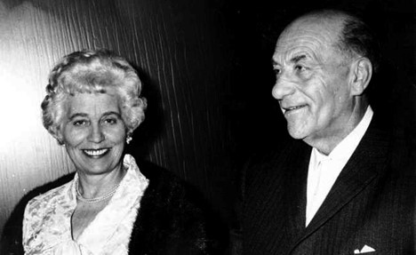
Dr. Siebinga died in 1969 in a traffic accident at age 71. Tina returned to the U.S. in 1971, first taking care of her mother. After her mother’s death, she lived with her sisters.
Soon after the war, Tina received certificates signed by General Dwight D. Eisenhower and Marshal of the Royal Air Force, Arthur Tedder, on behalf of the American and British governments thanking her for her aid to Allied airmen. In 1983, the Dutch government honored Tina and Dr. Siebinga (posthumously) with the decoration for members of the Resistance, known as the Verzetsherdenkingskruis, or Resistance
Memorial Cross. Tina said, “It’s about time!”
Tina kept in touch with several of the airmen after the war. After she moved back to the U.S. in 1971 and was living with her sister Patricia in San Jacinto, Paul Moseley came to see her.
Tina died Feb 6, 1984 in San Jacinto. Her family scattered her ashes to the winds. Tina’s brother, George, a member of the VFW post in Nevada City, and himself a Pearl Harbor survivor who served in the South Pacific, sought to preserve her memory with the plaque in front of the Veterans Building.
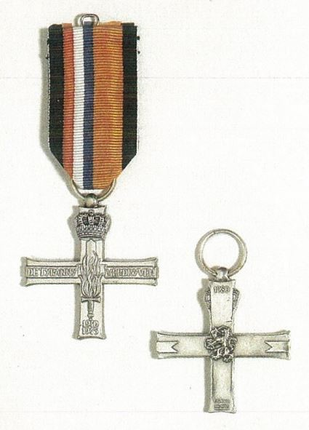

members attended the 8 Air Force Historical Society Reunion in New Orleans. There were
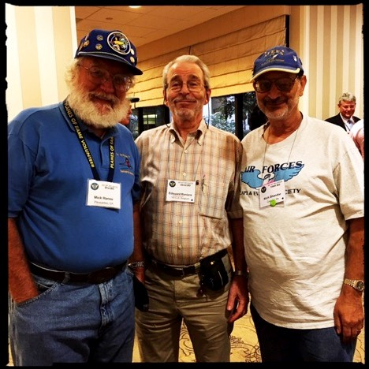
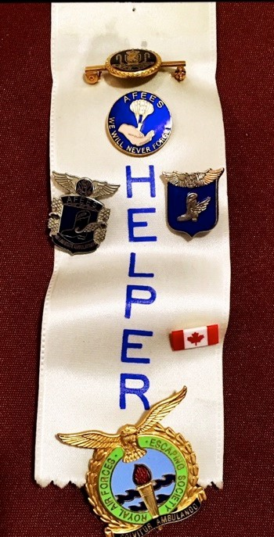
Veteran Q&A, committee meetings, group photos, visits to the incredible National World War II Museum, and individual hospitality suites! The gala Saturday night banquet was held at the Museum.

Mick Hanou, Edouard Reniere, Rich Shandor

AFEES in NEW ORLEANS

This
September,
several
AFEES
th
tours of local attractions, guest speakers,

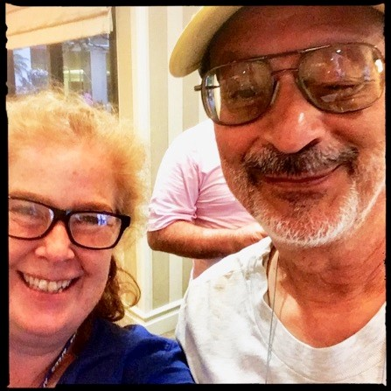
Elizabeth McDade and Rich Shandor

Mick Hanou’s mother, Neeltje "Case" Hanou
(nee Van Graafeiland) 1923-2010, was an honored member of the resistance in The Netherlands.

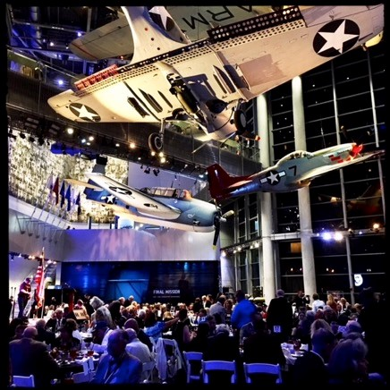
^{th} Air Force Historical Society
View of the 8
Reunion Saturday night banquet at the National World War II Museum.

FRÉTEVAL FOREST EVADERS HELD REUNION – BEFORE THE WAR ENDED! by Jerri Donohue
Cleveland newspapers were still printing casualty lists in August 1945. They covered the homecomings of emaciated American ex-prisoners of war from the ETO and speculation about Japan’s expected surrender dominated the headlines. Perhaps as a welcome diversion for war-weary
Clevelanders, all three of the city’s major dailies featured the reunion of the “Escadrille Soixante-Neuf” at the Hotel Cleveland from August 12 through 14.
One of the first fraternal organizations to result from World War II, the Escadrille consisted of forced-down Allied fliers who avoided capture by hiding in the Fréteval forest southwest of Paris.
For attendee Jack Pearson’s often hilarious account, Google “Fréteval Reunion Report – Cleveland 1945.” It sometimes reads like a frat boy’s fond recollection of a boozy party. In today’s parlance, that first reunion was “epic.”
The newspapers took a more sober tone.
“These men – most of them are youngsters – who have brushed close to death on war missions have taken on a peace mission,” wrote the Plain Dealer’s George Scofield. “The theme of their convention will be cementing more friendly relations among the Allied nations.”
As many as 150 downed fliers from South Africa, Australia, New Zealand, Great Britain, Canada, Belgium, Poland and the United States waited out the final months of the war in the French forest. According to newspaper coverage, 44 people attended their first reunion. These included Commandant Pierre Benedictus of the French Air Mission and the U.S. Fifth Armored Division’s Captain Karl Roth, who helped liberate the evaders. Pearson counted 11 Canadians and 10 Americans at the reunion. All wore their uniforms in newspaper photographs, and a reporter commented on the slate blue Canadian garb spotted among American khaki.
In that era before interstate highways, these young men traveled considerable distances and even crossed a border to spend time together. Some arrived days early and others departed late. According to evader Pearson, at least one went AWOL to attend. Another made the trip even though his first baby was arriving any minute. As a group, they celebrated Japan’s surrender. Sadly, the sole Clevelander, Lt. Ralph Hall, missed the reunion because he was stationed at Turner Field, Georgia.
The oldest evader in attendance was 33-year old Sgt. Emmett Bone of Port Arthur, Texas. Two days after he was shot down in early February 1944, Bone made contact with underground members, who then shuttled him around France. On June 2 they moved the American to one of the Fréteval camps where he remained until liberation on August 13. Newspaper accounts gave a peek at the conditions in which the men had lived. Lt. Max Harrell of St. Charles, Louisiana compared their forest home to a “hobo jungle.” They slept on the ground, did assigned KP duties and laundry chores, and posted sentries day and night to watch for the enemy. Sometimes the British air-dropped them food and such necessities as shoes, shirts and rum. The evaders constructed a makeshift golf course, used tree branches as clubs and whittled jumbo-size golf balls. (During their first reunion, the men played golf at the Lake Shore Country Club.) At one point, a German company camped across the road from them,
restricting their activity
Flight Sgt. Sam Dunseith, a tail-gunner from Woodstock, Ontario told a reporter about his escape from a burning Lancaster. As he tried to exit the plane, Dunseith’s foot caught in the door. He dangled in the air, repeatedly slamming against the aircraft before finally breaking free. His face was badly burned and he was temporarily blind when a French farmer rescued the Canadian the following morning and delivered him to the Maquis. The underground then hid Dunseith in a forest. Two weeks passed before anyone could treat his burns; his “medic” was a Belgian airgunner. Dunseith was still blind when he arrived in the Fréteval camp. His face was badly scarred but he eventually recovered his sight.
Newspapermen noted the evaders’ eagerness to speak of the heroism of their helpers. Without identifying individuals, Dunseith and other interviewees praised the civilians who risked everything to keep them out of enemy hands.
One newspaper quoted Flight Lieutenant William F. Bender of Kitchener, Ontario.
“Our folks at home must be made to realize what we and countless other airmen owe to the French,” Bender said.
The men determined to maintain warm relationships with their Allies.
“We’ve learned that life’s too short to waste any of it hating our own kind of people,” said Flying Officer William Brayley of Montreal, the group’s international secretary.
“There are important hates that we’ve decided to concentrate on – tyranny, dictatorships and the way of life that goes with them.”

POLISH PARTISANS PROTECTED DOWNED FLIER
by Jerri Donohue
(DD 214 Chronicle, September-October 2017 issue; reprinted with permission)
Richard Hansler knew that German fighter pilots sometimes fired upon Allied fliers who parachuted from crippled planes. Hoping to escape their notice, the navigator delayed opening his parachute when he jumped from a B-17 on September 13, 1944.
The ploy worked.
“When my ‘chute opened, I wondered if I might be in Heaven,” the 93-year old Pepper Pike resident said. “After all the chaos of being in the plane, [there was] the complete silence, and the beautiful surroundings of the fields and the mountains.”
Hansler’s crew had dumped their bombs on a synthetic gas manufacturing plant in Blechhamer, Germany. As they left the target, an explosion knocked out two engines, the radio and their oxygen system. Enemy fighter planes attacked when they were forced to drop altitude in order to breathe. Realizing the aircraft would never reach Allied territory, the crew bailed out.
Hansler landed in what was then Slovakia. Farmers who witnessed his descent hid him in the woods.
After dark, a man took the American by oxcart to a nearby village. The Germans arrived for a house-to-house search and Hansler fled up the mountain. His helpers then turned him over to Polish partisans who led the flier across the border into Poland. He reunited with three crewmembers and he learned the Germans had captured five others.
“The Major,” a middle-aged veteran of the Polish army, led a band of 50 partisans who lived in tents while the airmen usually slept in local homes. They gathered at a designated spot for meals, surviving on eggs, potatoes and cabbage. Hansler carried a pistol and took his turn at guard duty.
The group occasionally blew up bridges or ambushed enemy convoys. Hansler participated in one such mission, but the Germans retreated as soon as a nervous partisan opened fire.
The Poles wanted nothing to do with the approaching Red Army.
“They hated the Russians as much as they hated the Germans,” Hansler said.
The Major knew the Soviets could get the fliers home, however, and so he delegated Hansler and a Canadian to make contact. A Russian patrol delivered the two men to a drunken sergeant who assumed they were Germans and prepared to shoot Hansler.
Nobody spoke English, but a sober corporal realized Hansler was American and interrupted the intended execution. Hansler and the Canadian fetched the other Allied airmen – which by then included an Australian, a New Zealander and another American crew. The Russians trucked them all to the rear where Hansler collapsed with pneumonia. He spent six weeks in a Red Army field hospital before traveling alone by train to Odessa.
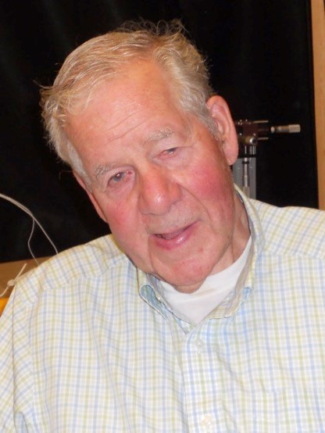

Richard Hansler

Shortly before the war ended in Europe, he sailed to Naples with hundreds of other Allied servicemen stranded in Russia.
Hansler’s ordeal was over, but his family’s was not. For months the navigator had been listed as Missing in Action. He sent his parents a telegram from Italy to confirm he was alive.
“My poor parents suffered a lot more than I did,” Hansler said.
(Dick Hansler’s evasion account, Prepare to
Bail Out!, is available on amazon.com.)

Dick Hansler was shot down on his 25th mission. At that time, airmen in the 15th Air Force needed to complete 30 missions before going home. “Of course when they [crews] got to thirty, they changed it to fifty – and so we probably wouldn’t have got home anyway.”

BRUSSELS COMMEMORATIONS
This fall, Margy Fricke and Bruce Bolinger made arrangements for AFEES representation in Brussels. Margy attended the Comète Remembrance Reunion. Brigitte d’Oultremont made arrangements for Margy to lay flowers on behalf of AFEES at a ceremony in the Cimitiere de Schaerbeek at the graves of Dédée De Jongh and her family. A new plaque will be dedicated. Flowers were left on behalf of AFEES at the Comète stained glass window during the service at the Koekelberg Basilica. Dirk Vijverman who has the AFEES flag and has appeared at several commemorations representing AFEES and Jean-Marie Schrynemakers were at the
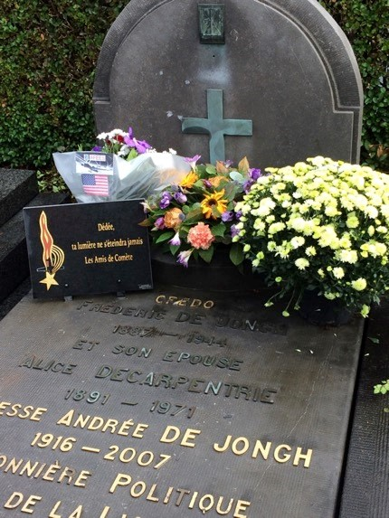
ceremony
.

Bruce Bolinger made sure AFEES was represented in a ceremony commemorating Remembrance Day (which goes back to the end of WWI) combined with the 71st anniversary of the founding of the Belgian Air Forces Association (BAFA) at the Parc du Cinquantenaire in Brussels.
Bruce’s cousin, Jean-Marie
Schrynemakers, who lives in Brussels and is a member of BAFA, suggested AFEES participate in the event. Dirk Vijverman also attended the event. A letter from John Katsaros to General Guido Vanhecke, president of BAFA, was presented at the ceremony.
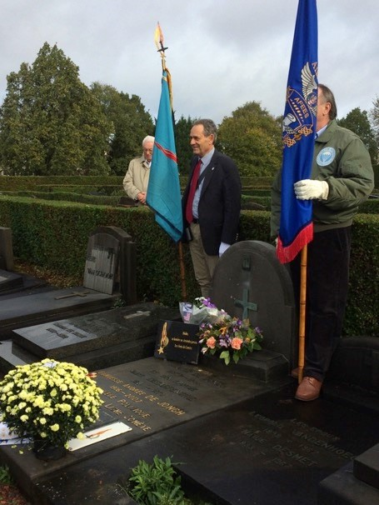

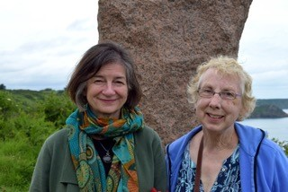

FOLLOWING IN THE FOOTSTEPS OF SHELBURN
In June, Mary Spinning Shier and Beverly Patton Wand traveled to Plouha in Brittany to remember the people who helped their fathers evade capture from the Nazis and to commemorate the Shelburn network. They were interviewed by “Spotlight on Brittany.” Click here to listen to the interview: http://www.radiobreizh.bzh/fr/emission.php?e mid=20

WORLD WAR II FLIER'S GRANDDAUGHTER RETURNS TO FRANCE FOR HONORS
Herald & Review, edited for space and reprinted with permission
While serving as a bombardier with the 8th Air Force, Lt. Robert “Peck” Wilcox was shot down over France.
A French family hid him from the Germans for more than eight months, believed to be the longest any American was protected from the Nazis in occupied France. That was more than 70 years ago, but the people who live where Wilcox was hidden, have not forgotten him nor the brave people who risked their lives to rescue him.
In 2016, as part of the festivities to celebrate the 70th anniversary of the victorious end to World War II, a ceremony was held in the tiny southwestern town of St.
Simon de Pellouaille in December to honor Wilcox and his French benefactors.
Wilcox, who served as a rural mail carrier in Blue Mound, TX after the war for 23 years, died in 1999. When the French people reached out to his family to send representatives from across the ocean for the ceremony, it was fitting that his granddaughter, Kari Foster, decided to make the trip.
Foster, who grew up down the road from her grandfather and was close to him, was contacted via Facebook in November by an Englishwoman living in France who was hired to try to reach the aviator's family.
“I was a little skeptical,” Foster said, adding that the contact was facilitated because she posted the story of her grandfather's adventure on the social media site.
The ceremony was scheduled to take place just a few weeks later. Foster tried to persuade some of her family members to join her. But they were busy, so she made her first overseas journey by herself.
In addition to her connection with her grandfather, whose memory she serves by keeping his diaries and newspaper clippings of his return visits to France, Foster has become friends with French people who were acquainted with Wilcox.
Bernard Ballenger, who has written articles on the war, visited Blue Mound in October with his wife, Dominique, and two grandchildren.
“They put French flags on my grandparents' graves,” Foster said. “They're in the Hall Cemetery in Blue Mound, right behind our house.”
So when the Ballengers heard about the ceremony, they offered to host Foster during her visit. They met her at the Bordeaux airport Dec. 16.
“They took me sightseeing every day,” Foster said, adding she finally got to see for herself the sites she had heard so much about from her grandfather. “They took me on the route he walked before he was hidden. They showed me where my grandfather bailed out and landed.”
She got to see the distillery where Wilcox hid the first night he was on the ground.
“The next night, he came upon Frederic, a teen who was on a bicycle. Frederic took him home and told his mom and dad, 'Here is an American.' They decided to hide him.”
Wilcox was kept mostly in an attic, over a stable. “No one else in the little village knew he was there,” Foster said, adding that her grandfather was a farmer, just like the people who hid him.
On the day of the ceremony, Foster was driven in a procession in a restored U.S. Army mail van, apparently left over from the days when soldiers swarmed through France en route to Germany.
The Nadeau family, including
Frederic, were no longer alive, Foster was moved to see the graves of the people who saved her grandfather.
Foster met an 85-year-old woman named Helen, who lived next door to the Nadeaus. She said that she and her husband were friends with Foster's grandfather. During his visits to France, he would frequent their grocery store and buy gum from them.
“He wrote them constantly, two or three times a month to different people,” Foster said. Wilcox had learned some French during his stay at the Nadeau farm. “He would write his letters in French, using the
dictionary.”
The people who attended the ceremony expressed their gratitude for what the
Americans did to liberate their country.
The plane in which Wilcox flew on Dec. 31, 1943, was never recovered. After antiaircraft flak opened a hole in its nose and caused an engine fire, the crew bailed out and the plane crashed into the ocean. Wilcox had dropped the bombs as they approached their target, the Cognac airport.
One of the greatest gifts Foster received was a collection of seven pieces of an American plane, recently recovered in the area, which was shot down during the same mission as Wilcox's B-17 bomber. It was given to her by Michel Souris, a man who has found more than 6,000 pieces of that plane through his determination to unearth and preserve history.
“A lot of people in the area are interested in the history of what the Americans were doing there,” Foster said.
She had many unforgettable experiences in France, including visiting the room where her grandfather had been hidden.
The trip was a magnificent adventure, meeting so many people who let her know that Americans, especially her grandfather, were important to them. She was proud to represent Peck Wilcox and the men who flew with him to liberate Europe.
“That was one of the biggest honors I ever had,” she said.

Q: How do you know if there is a fighter pilot at your party?
A: He'll tell you. Q: What's the difference between God and fighter pilots? A: God doesn't think he's a fighter pilot.
Q: What's the difference between a fighter pilot and a jet engine? A: A jet engine stops whining when the plane shuts down.

MOVIES / BOOKS OF INTEREST
“THE DARKEST HOUR” is a thrilling and inspiring true story that begins at the precipice of World War II as, within days of becoming Prime Minister of Great Britain, Winston Churchill (Academy Award nominee Gary Oldman) must face one of his most turbulent and defining trials: exploring a negotiated peace treaty with Nazi Germany, or standing firm to fight for the ideals, liberty and freedom of a nation. This film will be released in movie theaters Thanksgiving weekend (November 22, 2017) and may be a great idea for a fun and informative family outing.

“DUNKIRK” In May 1940, Germany advanced into France, trapping Allied troops on the beaches of Dunkirk. Under air and ground cover from British and French forces, troops were slowly and methodically evacuated from the beach using every serviceable naval and civilian vessel that could be found. At the end of this heroic mission, 330,000 French, British, Belgian and Dutch soldiers were safely evacuated. This film was released in movie theatres this summer but the DVD will be available around Christmas.

“THEY CAME FROM BURGUNDY, A STUDY OF THE BURGOGNE ESCAPE
LINE” is a recent publication by Keith Janes. He writes, “Of the three major escape lines running through France during the Second World War – the Pat O’Leary line, which covered most of the country, the Comete line, which ran from Holland and Belgium through France to the Pyrenees, and Bourgogne – Bourgogne (aka Burgundy) is the least well known.
For those who were involved, the helpers or benefitted from them, this was a personal war, which was, and remains, almost unknown to the outside world, despite the tragic loss of so many of those concerned.
This study, which is based around contemporary reports and documentation, as well as extensive personal research by the author and others, describes the evasions of the more than three hundred Allied servicemen helped by the Burgundy line, together with details and the eventual fates of many hundreds of their helpers.”
For further information, see the author’s website at www.conscript-
heroes.com/escapelines/they-came-fromburgundy.htm

FREE COPIES OF “EVADE” DVD
In 2004, the Air Forces Escape and Evasion Society and the Friends of the Air Force Academy Library collaborated on the production of a DVD entitled EVADE! It contains interviews with American airmen who were shot down during WWII and who escaped capture as well as helpers of such airmen plus extensive documentation about escape and evasion in WWII.
While the DVD is free, there is a $3 shipping and handling fee. To order a free copy of the DVD, please contact Bruce Bolinger at bcbolinger@comcast.net. This DVD is available to anyone interested in these interesting and amazing stories.

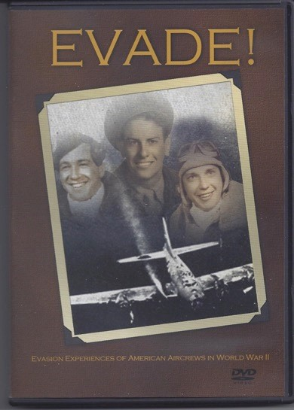
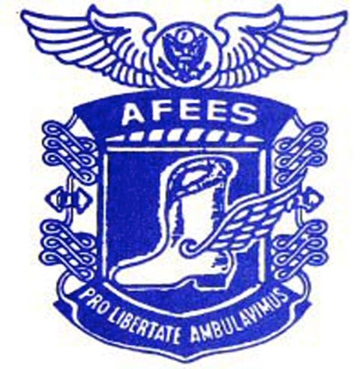

FOLDED WINGS

ED MILLER (E&E #693) died December
2, 2016.
A co-pilot, Ed Miller arrived in England in September 1943 and was assigned to the 328 Bomb Squadron, 93rd Bomb Group. On January 7, 1944, his crew bombed the IG Farben factory in Ludwigshafen, Germany. Flak over the target knocked out one engine of the B-24. The plane lost a second engine flying through another flak barrage and could not hold altitude. It stayed aloft until flak somewhere near Paris set one of the remaining two engines on fire and the crew bailed out. In the pandemonium, radioman Willis Spellman exited the plane with Ed’s parachute but Ed found Spellman’s chute and managed to jump, too.
Ed sprained his ankle when he landed inside a fenced- in area containing a German radio transmitting station. Expecting to be captured, he approached a sentry post but found it empty. Apparently the Germans already were chasing another crewmember.
Five of the men became POWs.

Ed hid under a rock and later in a latticework arbor. The first civilians he approached ordered him to move on. For several days, the evader hobbled along on his injured ankle, heading for Spain. Early on, a man gave him dinner but urged him to surrender to Germans living in his building. On another occasion, an elderly man made breakfast for Ed and whispered a warning that his son was a collaborator who would alert the Germans as soon as the flier left their home.
Ed usually walked under cover of darkness, sometimes because he was too cold to sleep in freezing temperatures. Several people refused him shelter but others allowed him to sleep indoors.
The pilot hid the fur collar of his leather jacket under a scarf. Still wearing flight boots, he tromped through Melun in moonlight. Two bewildered German officers merely stared at him. In one town, a priest gave the American coveralls and a pair of shoes.
Sometimes the evader trailed groups of people going to and from work. One rainy Sunday when nobody was on the road, he walked all day. His feet were blistered and bleeding when he met young villagers who summoned Marcel Raffard, an elderly man who had lived in Manhattan for 15 years and spoke fluent American English. Raffard went to the site where Ed’s bomber had crashed, and learned from local people that two of the crewmen had been shot to death by German ground troops. The engineer was hospitalized.
Ed’s helper left on bike every day to discreetly seek help. After a mayor put Raffard in touch with the underground, a young Frenchman took the American to Paris by bicycle, bus and train.
Ed stayed in an apartment with two Frenchmen who worked during the day. He received a fake ID card and his helpers recklessly took him sightseeing – a favorite pastime of enemy soldiers on leave. At the tomb of the Unknown Soldier, a German delegated Ed to hold his rifle while he took pictures.
The underground moved Ed to the outskirts of Paris to the home of a woman named Charlene. She eventually took Ed and two other evaders by train to the south of France. The Brits bombed Orleans when the train stopped there, blowing out the windows in Ed’s compartment. Arriving in Tarbes, the men waited in a safe house for three days to cross the Pyrenees. The underground gave them shoes and cleats, which Ed affixed to his new footwear.
By now it was the end of March. The mountain crossing took three and a half days; on the final day they walked in a blizzard. In addition to the Americans, the group included a French doctor and his son, and a Frenchman going to England to join DeGaulle’s forces. They were relayed from one guide to another, all of whom rushed the men through the snow. They reached Spain on March 31, 1944, and billeted in comfortable private homes. After a comical interrogation by Spanish police, the Americans headed for Gibraltar, finally arriving on May 29, 1944 because of a few lengthy stops along the way. They flew to England the following day on a C-47 full of wounded Brits. After debriefing, the evaders remained under lock and key in London until somebody from their base identified each man. To receive his flight pay, Ed later flew as a co-pilot on D-Day, after which he immediately was grounded and sent home to New York City.
Ed corresponded with Marcel Raffard after the war. Upon liberation, Raffard had traveled with GIs, serving as an interpreter even though he was well into his 70s. (Some of Ed’s other helpers were Pierre Demorge and Charles Astrue.) Ed learned that Sergeants Willis Spellman and Robert
Fruth from his crew also had evaded capture.
At the 2000 AFEES reunion in Missouri, Ed and French helper Marguerite Brouard Fraser shared a limo from the St. Louis airport to Columbia. During the long ride, the two discovered they had a lot in common, and they married a couple of years later.

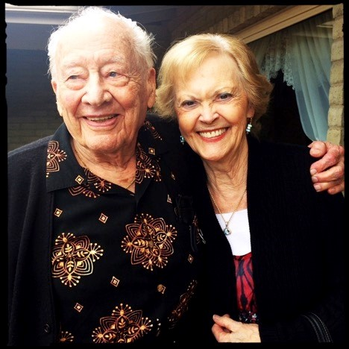
Ed and Marguerite Brouard Miller

Despite his harrowing experiences, Ed saw humor in his evasion adventure. On his reasons for joining the Army Air Force, he said, “I figured soldiers had to walk, and I didn’t want to walk. Unfortunately, when I was shot down, I ended up walking half way across Europe.” (Jerri Donohue)

JOSEPH J. WALTERS (E&E #224), a veteran of the 381st Bomb Group, 535 Bomb Squadron, died on September 12, 2016 at age 103.
The ball turret gunner on Chug-a-lug Lulu, a B-17 whose nose art sported an ape drinking beer, Joe was dubbed “the Deacon” by his crewmates. He was the oldest at age 30, a temperate drinker and the only married man among them.
On their first mission, the crew accidentally shot down the commander of a Spitfire squadron. The officer survived, but the bomber crew received further instruction in aircraft identification. During a subsequent raid on Hamburg, Joe’s electrical suit shortcircuited and he spent three hours in sub-zero temperatures, suffering frostbite to his hands and feet.
On August 17, 1943, the Chug-a-lug
Lulu sustained damage from fighters and flak during a raid to Schweinfurt. After dropping its bombs, the aircraft could not keep up with the formation and German fighter planes again attacked. The pilot ordered the crew to bail out when they were reduced to one working engine. It was their 15th mission.
A German fighter plane circled Joe as he descended, but didn’t fire on him. When his parachute opened, Joe wrenched his back and he fainted before reaching the ground. He awoke dangling from a tree near Boirs, Belgium.
Flemish-speaking civilians extricated him, and then Delbert and Lambert Tilkin spirited Joe to a barn loft, where he squeezed into a small space beneath floorboards. The Tilkins piled boxes around his hiding place. Joe remained in this tight spot for six hours, sometimes hearing Germans moving hay and tromping around on the roof as they searched for him. After the enemy left, the underground moved Joe to the home of Joseph Godin Peters. Teenager Janine “Sweetpea” Dardenne served as interpreter for the underground. Joe switched into workman’s clothing. Outfitted with a pick and shovel, he joined Sgt. Kenneth Fahnke the next day in a foundry. Fahnke had been shot down on the same day as Joe, and in the same area. The underground kept the two men together for much of the time they evaded.
Joe and Fahnke then stayed with a priest in Liers, where they joined three other members of Joe’s crew. All five Americans moved to Liege where they found shelter with Dr. Charles Kramer, a podiatrist. Four more Allied airmen gathered there before Joe, Fahnke and a third evader traveled by train to Brussels to the home of Monsieur and Madame Katz. Joe later lived with Monsieur Rene Pirate.
Guides eventually escorted Joe and
Fahnke to Blandain. The little group entered France by bribing border guards, reached Lille by bus and then proceeded to Paris by train.
Madame Germaine Bajpai and Madame Daisy Benoit hid Joe in Paris. He later reunited with Fahnke for the trip south to the Pyrenees, guided by an unidentified woman. In 2012, Joe recalled harrowing episodes of that trip. He witnessed a Canadian shoot a German and toss his body from the train when the enemy demanded to see his papers. Joe’s helper had her charges exit the train and bicycle the remaining 50 miles to the mountains.
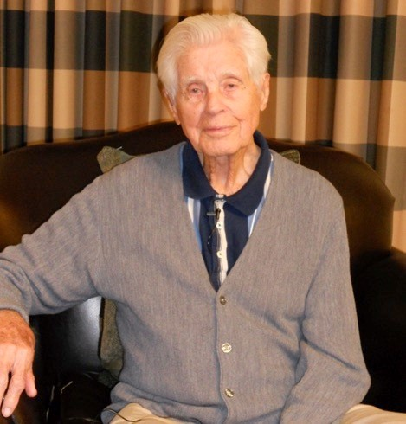

Two Basques accompanied Joe’s party across the Pyrenees. Joe lost one ill-fitting shoe in the dark. Once in Spain, the men surrendered to Spanish authorities who gave them breakfast and later transported them to Irun. The American consul visited the evaders and gave them money, but they remained in Irun for five weeks. The last legs of their journey included stops in San Sebastian and Madrid. They unhappily shared a train with “Blue Division” soldiers, Spaniards who had fought for the Germans in Russia. Joe finally reached Gibraltar and he returned to England on November 20, 1943. The BBC informed the underground with the message, “Rabbit is back in the hutch.” Joe discovered that his crewmembers Thomas Moore and Otto
Bruzewski also had evaded capture.
Throughout his evasion experience,
Joe was mindful of the risks his helpers took. He was forever grateful to the men and women who’d helped him. He contacted them in post-war years, and he returned to Belgium to see them in 1998. Janine Dardenne married an American and Joe reunited with her in the
States.
“The underground never got the credit they justly deserved,” Joe said. “They were wonderful, wonderful people.” (Jerri
Donohue)

RAYMOND JOHN FREDERICK SHERK
Raymond Sherk passed away on December 2, 2016 at the North York General Hospital in Toronto, ON at the age of 94. An adventurer at heart, Ray joined the Canadian Army in May 1939, transferred to the RCAF in September 1940, earning his Wings in April 1941. He went overseas a month later, completed his operational training and then joined the 129 RAF (Mysore) Squadron at Tangmere in August 1941 as a Sergeant. Ray flew with this Squadron for 9 months until he was transferred to the Desert Air Force in April 1942 as a Pilot Officer. He flew Hurricanes and Spitfires in 73, 74 and 601 RAF
Squadrons in the Middle East.
On September 29, 1942, while on a mission to intercept an ammunition train at an important rail junction known as ‘Charring Cross’ near Mersa Matruh, Ray made a forced landing over Northern Africa. He was captured the next day while attempting to walk home through the El Alamein front line. He was transferred to Italy, first PG75 Bari and then PG78 Sulmona where he was a POW for one year, and celebrated his 21st birthday in prison. With the capitulation of Italy in September 1943, Ray fled to the mountains with friend Don McLarty. They hid in a cave near the town of Roccacasale for several days before hiking through the Apennines disguised as shepherds. They came upon the Canadian Seaforth Highlanders 45 days later. It was during this escape that Ray met South African war correspondent Uys Krige, who later introduced Ray to his wife Heather in 1968.
Ray returned to operations with the RCAF Squadron 401 in February 1944. On March 15, 1944, Ray’s Spitfire engine failed during a bomber escort mission over Northern France. He parachuted onto the Hawthorn Ridge, adjacent to the Beaumont-Hamel Newfoundland Memorial. With the help of nearby farmers, Ray was hidden in a haystack to evade German capture. He was sheltered by the French Resistance for 3 weeks, primarily in the village of Hébuterne, and then guided south by train. He was arrested in Amiens, but managed to slip away to catch a departing train. Ray walked the last 100 miles to the Spanish border, and found another guide to lead him over the Pyrenees. Once back in England, Ray sent a BBC radio message to his helpers: ‘The Sky is Blue’ signalling his safe return.
Ray was a founding member of the Royal Canadian Escaping Society, an organization dedicated to the recognition of the extreme efforts and risks taken by those families who assisted airmen escape or evade capture by the Germans during WWII. He felt eternally indebted to his Italian and French helpers, and he and Heather were honoured to host them in Canada over the years. He remained lifelong friends with his helpers and their families. Ray also served on the AFEES Board of Directors for many years.
Ray had a true passion for flying, and continued doing so after the war in the 400 Reserve Squadron. He also worked as a pilot and flight instructor at the Toronto Island Airport in the 1960s during his summer breaks from teaching, and flew 14 CNE Air Shows, some with demonstrations using live ammunition.
When he was 79 Ray was the only WWII veteran to complete ‘The Freedom Trail’ in 2001, a 3-day 60 km hike over the Majella Mountain in Italy, retracing the historic path taken by escaping Allied prisoners. Ray wore his WWII army issued boots for the hike, which fascinated his Italian hosts.
Ray appreciated and enjoyed the simple pleasures in life, and had a generous nature, always helping others in need. He was a modest man with many interesting and unique life experiences, and only when prompted would quietly share his stories with others. Amongst his experiences, Ray enjoyed high tea with the Queen of England, and a Heineken with Prince Bernard of the
Netherlands in 1969.
Ray was a mentor and role model, and his remarkable life was an inspiration to those who were privileged to know him. “Per Ardua ad Astra” (Toronto Globe and Mail)

STANLEY E. STEPNITZ (E&E #1348) died on August 26, 2015. He was 93 years old.
The grandson of German immigrants, Stan interrupted his college education to enlist as an aviation cadet in September 1942. He wasn’t called up until March 1943 because of the large number of cadets. After his initial flight training, the Army Air Force decided to make him a fighter pilot, after which it sent him to England. Stan became part of the 9th Air Force, 378th Fighter Squadron, 362nd Fighter Group.
Stan eventually flew out of a base near Maidstone, England, often dropping bombs on trains, railroad tracks, and airfields in France or shooting up German vehicles and aerodromes. When the Allies captured enough air bases in France to station airmen there, he relocated to A-12 (the 12th American airbase) in Normandy. In early August 1944, his whole unit transferred to A-27 near Rennes, Brittany.
Stan completed 30 missions and he deserved a promotion to 1st lieutenant. On August 20, 1944, however, the Germans froze his rank during his 31st mission.
An anti-aircraft shell pierced his P-47 at the oil line. Oil spewed onto the engine, and black smoke billowed off the fuselage. Without oil, the prop ceased to function properly and Stan knew he had to bail out. With one hand bleeding from a shrapnel wound, he unbuckled his safety belt and shoulder harness, removed his headset and rolled back the canopy. The wind knocked him back into the cockpit when he stood on his seat. He successfully exited the plane on his second attempt and deployed his
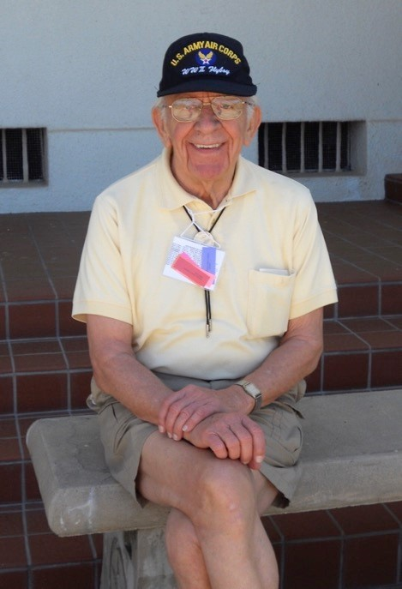
parachute.

Stan injured his left ankle when he landed hard in a field near Beuzeville in German occupied territory. He threw his ripcord ring in one direction and sprinted for the other.
He ran until pain forced him to stop. Stan rested on a log, unlaced his shoe and watched his ankle swell. During his second rest break, three boys approached him. The oldest, 16-year old Pierre Quesney, spoke English. After confirming that Stan was an Allied pilot, he told him to hide and wait for his older brother. Stan burrowed into the hedgerow from 3 p.m. until 9 p.m. when the brother, François Quesney, took him to a farmhouse and fed him. He later moved Stan to a shed a quarter mile away.
The following day François and a friend arrived on bicycles. The friend abruptly left on foot, leaving his “wheels” to Stan. The injured American found it easier to ride the bike than to walk. He followed François to a 3-room building where the underground stored weapons under pillows, blankets and mattresses. Stan slept there for three nights.
En route to his next hideout, Stan and his escort stopped for a meal with a farm family. One of the children spotted a German soldier at the gate and the adults rushed Stan under a bed in a back room.
“This was the first time I got scared,” Stan admitted years later. “Flying combat and getting shot at, puffs of black smoke [flak] all over -I’m never scared. But here I am under the bed with a German soldier coming into the house and I am lying on my stomach, so scared my heart was pounding.” As it happened, the enemy only wanted directions. The French supplied these, as well as a sandwich.
Stan and Quesney then proceeded to the home of Monsieur Lorch, a paraplegic who served as the area’s resistance chief. Dr. Delamarre treated Stan’s ankle. Stan remained with Lorch until Allied troops liberated the neighborhood on August 26. To celebrate, Stan pushed his helper in his 3wheel cart into town so Lorch could show off his American. They also went to Dr. Delamarre’s house for cognac and cigars. When Stan spotted a British soldier, he greeted him with, “Hello, Limey!”
British officers refused to deliver Stan to Rennes, and so the evader hitched a ride with a motorcyclist headed in that direction, finally making it to an airfield. From there he flew to Bayeux. He was back in England by September 2.
Although the territory where Stan evaded had been liberated, his interrogation team insisted the pilot return to the States. He had learned too much about the underground to risk his capture if he were shot down again. Stan came home, still a 2nd lieutenant - a fact that rankled him decades later.
Stan viewed his evasion experience as an important episode in his life. He was a cheery, gregarious presence at many AFEES reunions. In 1950 he joined the Air Force Reserves. When he went to France in 1951 on assignment to retrieve a plane, he seized the opportunity to visit Monsieur Lorch, Dr. Delamarre and Pierre Quesney. François Quesney had moved away and Stan never saw him again, but he visited Pierre several times over the years, most recently in September
2010. (Jerri Donohue)

To see a 2013 video of MSU graduate Stan Stepnitz flying in a B-25, please take a look at this wonderful video on YouTube: www.youtube.com/watch?v=fFYuf_Cww6A

KENNETH AWTREY BROWER (E&E #2019) passed away on April 13, 2016. He was 96 years old.
Ken Brower was born in Greenfield, OK. Working alongside his carpenter father, Kenneth built a house on his own at the age of 16. His dad had offered him a new car once the house was completed for a local pastor.
In January 1938, Kenneth enlisted in the Oklahoma National Guard. After Pearl Harbor was attacked, the call went out by the Army Air Corps for aviation cadet applicants. Brower applied, took the test, and after being commissioned, he went to Hondo, completing navigator training in March 1943.
Lt. Brower shipped out for the European Theater of Operations in August
1943, and began flying combat missions in January 1944. Brower recalls his first flight during D-Day as lead crew navigator in his B26 Marauder. He watched the Battleship Texas firing their big guns and visually following the shells from ship to targets on the Normandy shoreline.
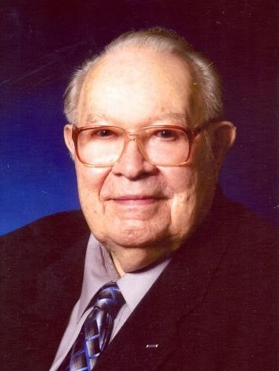

On his 46th bombing night mission, July 8, 1944, a German fighter attacked, forcing the crew to parachute from their flaming aircraft.
With the aid of the French
Underground in the village of BettencourtSaint-Quen, he hid for three months until liberated by the English.
He served in the Reserve until recalled to active duty in 1951. He flew 29 combat missions from Japan and Okinawa into North Korea. Returning to the U.S. he elected to remain on active duty in the United States Air Force. He served in the Strategic Air Command during the Cold War flying nuclear training missions in the B-58 Hustler from Carswell AFB, Amarillo AFB, and Bunker Hill AFB, Ind.
In 1967 he went to Southeast Asia, flying combat missions from U-Tapao AFB, Thailand, into Vietnam. "For Exceptional Contributions to the Liberation of France
during WWII," Ken was bestowed the rank of

Knight of the French Legion of Honor presented by the French Embassy in a ceremony at Naval Air Station Fort Worth in 2013. His other medals include the Purple
Heart, Distinguished Flying Cross, and Air Medal with eight clusters. After his retirement as commander of the troops at the Amarillo AFB in 1968, he returned to Fort Worth and to his first love as a carpenter. (Star-Telegram,
Ft. Worth, TX)

JETTY R. COOK (E&E #2145) of Hunt, TX passed away on September 6, 2016. He was 91 years old.
Jetty was born on September 29, 1924 in Coahoma, TX. His childhood years were spent in Big Spring, TX where he was in the class of 1943 of Spring High School. He entered the U.S. Army Air Corps and was called to active duty in March of 1943. He served in the European Theater of Operation during World War II on a B-17 crew.
On July 20, 1944, his plane was shot down and crashed in Belgium. He was able to parachute to safety and evaded capture by the Germans with the help of the Belgian Resistance with whom he established a lifelong relationship. He was freed when Belgium was liberated by U.S. Forces.
He received a direct commission of 2nd Lieutenant during the Korean War in 1952 and served in various command and staff positions until his retirement in 1975 for a total length of service of 33 years.
He served overseas tours of duty in Italy, Panama, Saudi Arabia, Germany and Spain. At the time of his retirement in 1975 he was a Squadron Commander at Torrejon AB, Spain (Madrid, Spain).
His military decorations include the Purple Heart and the Air Medal (w/1 Oak Leaf Cluster), plus numerous others, including the NASA Public Service Medal.
After retiring from the military he was hired by the Boeing Company as its Logistics Manager, Zaragoza Air Base, Spain. In early 1978 he was transferred to the Kennedy Space Center in Florida as Boeing’s Project Manager to provide logistical support to KSC
Institutional and Space Shuttle Operations.
After the Challenger Space Shuttle Accident he transferred to Pan Am Services Company as Support Services Manager at the National Laboratory in Los Alamos, New Mexico, where he worked until his retirement in 1988.
Lt. Col. Cook was a member of the Air Forces Escape & Evasion Society, the Air Force Association, and 92nd Bomb Group Association. In September 1994, Jetty and his wife Wanda, accompanied by his crewmate Melvin Crouch (E&E 2147) and his wife Barbara, returned to Belgium for a reunion with the brave Belgian patriots who had helped us evade capture. They timed this visit, Jetty’s sixth back to Belgium, to coincide with Belgium’s 50th anniversary of its liberation. Learn more about Jetty’s experiences during the war in his own words:
http://www.remember-history.com/myheroes/jetty-cook/

MORRIS ELISCO (E&E #713) passed away on August 9, 2015. He was 91 years old.
Staff Sgt. Elisco was a Radio Operator on a B-24 that crashed on March 18, 1944 near Vernon-sur-Seine northwest of Paris. The only member of his crew to successfully evade, Morris was helped by the Burgundy network (you can read about Morris’ experiences in They came from Burgundy: A study of the Bourgogne escape line—see page 21). According to the Elisco family, Morris stayed hidden for 6 months, made the difficult journey over the Pyrenees Mountains, and upon arrival in Spain, was put in jail by the Franco Regime.

REV. JAMES EDWIN ARMSTRONG
(E&E #339) folded his wings on November 3, 2016. He was 94. Born in Bradenton, FL, Jim attended Georgia Tech before enlisting in the US Army Air Corps in 1942. In the 8th Air Force, Jim served as a B17 bomber pilot and earned the rank of Lieutenant Colonel.
After completing his 11th mission to Stuttgart, Germany, Jim and the crew of the B-17 Yankee Raider crashed near Étrépagny, France on September 6, 1943. He parachuted to safety only suffering minor burns and a sprained ankle.
He spotted a Frenchman and showed him the phrase sheet from his escape kit. The man told him to hide in the woods. Jim stayed there for 10 days while being fed twice a day by the Frenchman. After his ankle got better, he started walking and, using his silk map and a compass shaped like a pocket watch, made his way towards Paris.
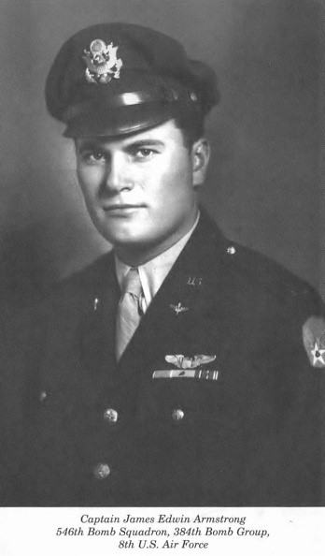

Members of the resistance picked him up and took him to the suburb of Drancy. In Drancy he and two Americans and an Englishman were provided with false identity cards—Jim became Jean Riber, a butcher.
By the end of October, the first of several attempts to make it back to England were put into action. The plan called for a PT boat off the coast of Quimper to take about a dozen allies to England. They made several attempts but were unsuccessful for a variety of reasons. Each time a plan failed, the airmen were taken back to Paris by train.
On January 21, 1944 they tried again. The tides were quite high. The plan called for the men to wait for the tide to go out and drift out under a bride. As they drifted under the bridge, they were told to “Halt!” but continued on past a German fortress. There were 31 men in a 30-foot fishing boat. Everyone was seasick. It carried a crew of two sailors, 12 Allied Airmen, and 19 Frenchmen who were going to join the Free French in England. There was a storm that night and the going in the Channel was very difficult. After two nights and a day, the boat landed in Falmouth, Cornwall England.
Armstrong’s book, "Escape!,” tells the harrowing story of his evasion via the
Shelburn line.
After the war Jim attended the University of Florida and in 1948 graduated with a BS degree. In Bradenton, he and his wife Nita were faithful members of First Presbyterian Church until 1961, when Jim answered God’s call to full time ministry. The couple, along with their three children, moved to Decatur, GA where Jim earned his Master of Divinity degree from Columbia Theological Seminary. Jim then pastored McCarter Presbyterian Church in Greenville, SC, followed by a pastorate at Friendship Presbyterian Church in Thomasville, GA. He founded New Covenant Church in Thomasville where he was privileged to serve until his retirement in 1984.

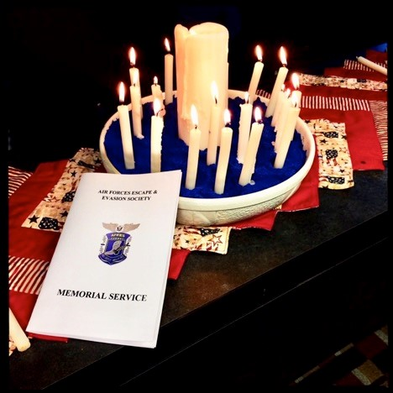

MILTON MOEN passed away on April 5,
2016. He was 91 years old.
He volunteered and served honorably in the US Army Air Corps from 1943-1945. During that period, he served in Europe with the 15th Army Air Force as a tail gunner in a B-17.
In December 1944 on a bombing mission over Vienna, his aircraft was damaged from flak and the crew bailed out over northern Yugoslavia. With the help of the Resistance he evaded capture by the Nazis for six weeks and traveled east through the Russian lines and was repatriated to US Forces by the Russian Army from Bucharest, Romania.
He evaded capture for six weeks. He was assigned to a new crew and continued to fly until the war ended.
After the war, Milton returned to Minnesota and married Helen Sjolie. He was a life-long member of Borgund Lutheran Church involved in many aspects of maintaining the church property and cemetery. He was a life member of the US Air Force Escape and Evasion Society, the American Veterans of Foreign Wars, and the American Legion.
_____________________________________

CHANGE OF ADDRESS OR NOTIFICATION OF FOLDED WINGS
Please let us know if your mailing address has changed or if you would like to get information via email. Additionally, please let us know if any of our Evaders or Helpers have passed away. All changes of address, emails, etc. should be sent to:
Jane Binnebose, 2515 2nd Ave. West, La Crosse, WI 54603, phone: (608) 783-6761 or email: jbinnebose@charter.net. Thank you!

A note from your Editor: Apologies are in order for the length of time between editions of your AFEES newsletter. Volunteers have had other commitments and life has thrown a fair number of hurdles in our way. Nevertheless, I am sorry for the delay in getting this issue of the newsletter to you. Please accept my humble apologies. If you would like to volunteer your services to help with the newsletter, let us know! And if you have articles or news items to be considered for inclusion in the newsletter, please send them to: afeesnewsletter@gmail.com.

____________________________________

AFEES Communications is the official journal of the Air Forces Escape & Evasion Society. AFEES was founded in 1964 as a nonprofit veteran's organization under IRS Code 501 (c) (19). The Society’s purpose is to encourage members helped by resistance organizations, or patriotic nationals, to continue existing friendships or renew relationships with those who helped them during their escape or evasion. Eligibility requires that one must have been a U.S. Airman, must have been forced down behind enemy lines and avoided captivity, or escaped from captivity to return to allied control.
_____________________________________

AFEES OFFICERS
PRESIDENT: John Katsaros, (978) 869-3035, email: jkatsaros3@comcast.net VICE PRESIDENT: Beverly Wand, (973) 377-3103, email: wandbandj@aol.com
EXECUTIVE VICE PRESIDENT: Lynn
David, (314) 422-1567, email: ldavid@airforceescape.com TREASURER: John White, (210) 416-0292, email: jwhite@swri.org
MEMBERSHP AND CORRESPONDING
SECRETARY: Jane Binnebose, (608) 7836761, email: jbinnebose@charter.net
RECORDING SECRETARY: Jane
Binnebose, (608) 783-6761, email: jbinnebose@charter.net HONORARY DIRECTORS: Gen. Duncan McNabb (USAF Ret.), email: duncanjmcnabb@gmail.com WEB MASTER: Bruce Bolinger, (530) 273-
6442, email: bcbolinger@comcast.net

OTHER DIRECTORS:
Margaret Fricke, (763) 571-4840, email:
frickej@comcast.net
Elizabeth McDade, (585) 262-3356, email:
afeesnewsletter@gmail.com Joe Owens, (863) 421-6986, email:
owenzelli@msn.com Mary Shier, (810) 793-4286, email: spwheel357@gmail.com Robert Wilson, (309) 243-5567, email: robertandsharonwilson@gmail.com Betty Hennessy, (562) 921-1494, email: bcjhennessy@verizon.net

THE PREZ SEZ
By John Katsaros (EE #755)
The Washington DC and the Lowell, MA office staffs along with Congresswomen Niki Tsongas are working diligently in an effort to get her new AFEES HR Bill 2279 accepted in the year 2018.
Representative Tsongas has been in contact with me that she has set a new strategy into effect to make this possible.
She expects to roll out the information regarding this over the next few weeks and the results will appear in the January 2018 AFEES Newsletter.
Congresswomen Niki Tsongas has requested, "that all AFEES and Helpers in the USA, along with your International Helpers, Members and Friends of the Evaders, join her and her staff in this great effort".
Unfortunately "time is of the essence.” Wouldn't it be wonderful to succeed?

We wish everyone a happy and healthy holiday season.

See you in Savannah!

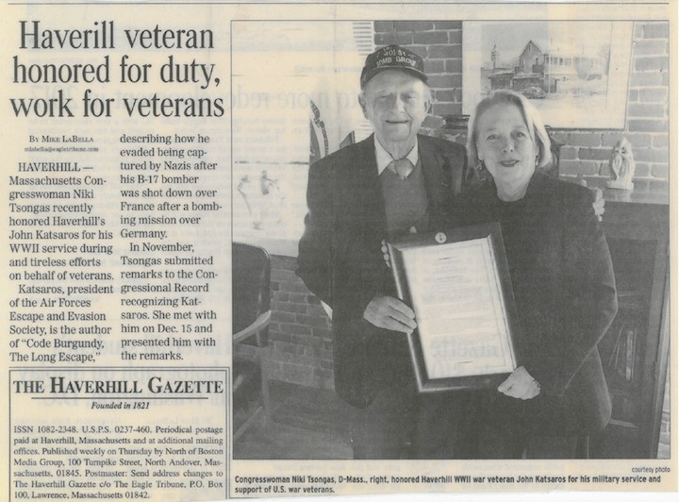

Congresswoman
Niki Tsongas
recently
honored

AFEES President
John Katsaros for
his
service and
work on behalf of
veterans
.

FROM

AFEES Publications

P.O. Box 254

CRESSON, PA 16630
-
0254

U.S.A.

Change Service Required

